**ASSIGNMENT_DAY-10**

**SUBMITTED BY: M.SANJANA**

**EMPLOYEE ID: 46255357**

**Assignment 3 – Business Add in (BADI)-Single Use**

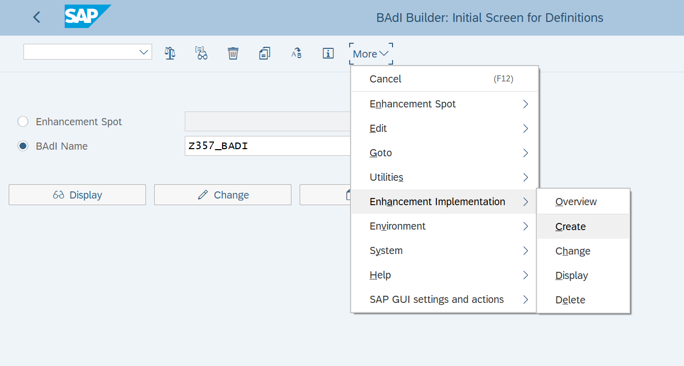

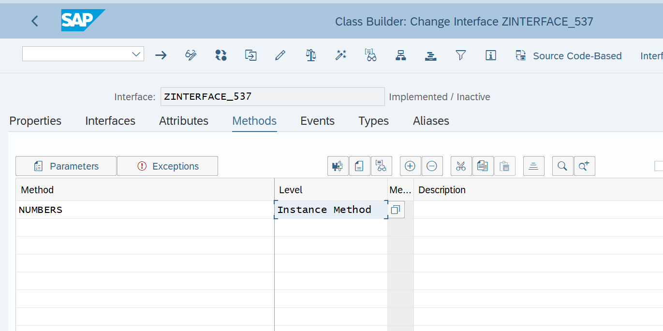

REPORT ZBADI_357.

START-OF-SELECTION. CLASS CL_EXITHANDLER DEFINITION LOAD.  
DATA: RESULT TYPE I.  
DATA OBJ1 TYPE REF TO ZINTERFACE_537.  
  
PARAMETERS: NUM1 TYPE I,  
            NUM2 TYPE I.  
  
CALL METHOD cl_exithandler=>get_instance  
  EXPORTING  
    exit_name                     =  'ZBADI_537   
*    null_instance_accepted        =  *  IMPORTING  
*    act_imp_existing              =  
  CHANGING  
    instance                      = OBJ1  
  EXCEPTIONS  
    no_reference                  = 1  
    no_interface_reference        = 2  
    no_exit_interface             = 3  
    class_not_implement_interface = 4  
    single_exit_multiply_active   = 5  
    cast_error                    = 6  
    exit_not_existing             = 7  
    data_incons_in_exit_managem   = 8  
    others                        = 9  
        .  
IF sy-subrc <> 0.  
* Implement suitable error handling here  
ENDIF.  
  
TRY.  
  CALL METHOD obj1->divide_numbers  
      EXPORTING i_num1 = NUM1  
                i_num2 = NUM2 .  
 CATCH cx_sy_zerodivide .  
  
   ENDTRY.

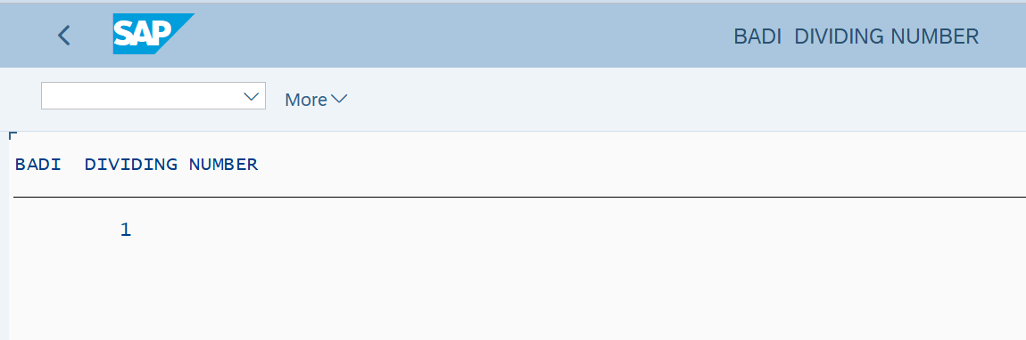

**Assignment 4 – Business Add in (BADI)-Multiple Use**

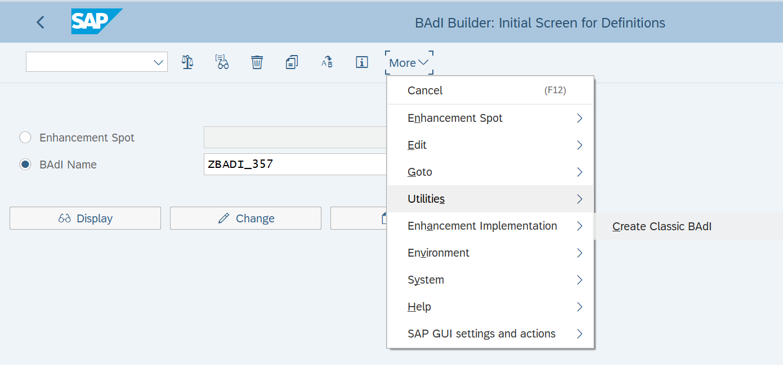

REPORT Z357_BADI.

DATA: VAR TYPE REF TO ZINTERFACE_357.  
  
PARAMETERS: p_carr TYPE S_CARR_ID,  
            P_flight TYPE S_CONN_ID.  
  
 CL_EXITHANDLER=>GET_INSTANCE(  
  exporting  
    EXIT_NAME                     = 'Z357_BADI'  
  changing  
    INSTANCE                      = VAR  
  exceptions  
    NO_REFERENCE                  = 1  
    NO_INTERFACE_REFERENCE        = 2  
    NO_EXIT_INTERFACE             = 3  
    CLASS_NOT_IMPLEMENT_INTERFACE = 4  
    SINGLE_EXIT_MULTIPLY_ACTIVE   = 5  
    CAST_ERROR                    = 6  
    EXIT_NOT_EXISTING             = 7  
    DATA_INCONS_IN_EXIT_MANAGEM   = 8  
    OTHERS                        = 9  
).  
  
CALL METHOD VAR->FLIGHT_DETAILS(  
  exporting  
    CARRIER_NAME   = P_CARR  
    FLIGHT_NUM     = P_FLIGHT  
  importing  
    FLIGHT_DETAILS = DATA(IT_FLIGHT)  
  exceptions  
    NO_DATA_FOUND  = 1  
    OTHERS         = 2  
).  
  
  
CALL METHOD VAR->GET_EMAIL(  
  exporting  
    CARRIER_NAME = P_CARR  
  importing  
    URL          = DATA(URL)  
).  
  
  
  
CL_DEMO_OUTPUT=>BEGIN_SECTION('FLIGHT DATA').  
CL_DEMO_OUTPUT=>WRITE_DATA( IT_FLIGHT ).  
CL_DEMO_OUTPUT=>WRITE_DATA( URL ).  
CL_DEMO_OUTPUT=>DISPLAY( ).

